NAME: SAGARSUMAN P MANJHI SUBJECT: PYTHON PROGRAMMING LAB | PRACTICAL: 11 | BATCH : 04  SYBVOC :SEM-III (DS)
EXPERIMENT BASED ON GUI PROGRAMMING USING TKINTER

AIM : To study and develop graphical user interface (GUI) applications using Python Tkinter by creating a Student Registration Form with labels, text boxes, buttons, and event handling to validate and display student details.
LEARNING OBJECTIVE :
  - To understand GUI programming using Python Tkinter.
  - To create labels, text boxes, and buttons.
  - To handle button-click events using functions.
  - To display student information dynamically.
  - To use message boxes for success and error notifications.
  - To clear input fields using event handling.
TOOLS :
Sr. No. | Name Of Resources | Specification | Quantity | Remarks
1. | Hardware | Computer (i5-i7) Ram (Min 16GB) | 1 | For All Practical
2. | Software | Python / IDLE / VS Code | 1 | For All Practical
THEORY :
Tkinter is Python's standard library for developing graphical user interface applications. It provides widgets such as labels, entry fields, buttons, and message boxes to create interactive desktop applications.
In this practical, a Student Registration Form is developed using Tkinter. The application accepts a student's name, roll number, course, and age. It validates the input, displays an error message if the details are invalid, and displays the registered student information when registration is successful.

Concepts Used
- Tkinter: Python's standard GUI library.
- Root Window: The main application window created using Tk().
- Label: Displays text or headings.
- Entry: Accepts single-line user input.
- Button: Executes a function when clicked.
- get(): Retrieves the value entered into an Entry widget.
- delete(): Removes text from an Entry widget.
- messagebox: Displays information, warning, and error dialog boxes.
- Event Handling: Connects button clicks to functions using the command parameter.
- pack(): Arranges widgets inside the window.
- mainloop(): Keeps the GUI running and responsive to user interaction.

Source Code:
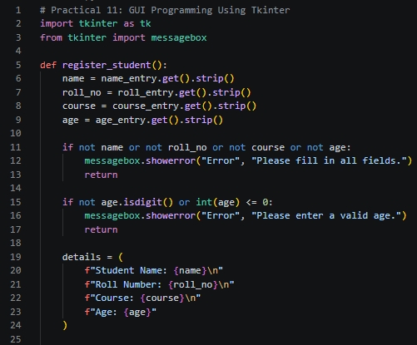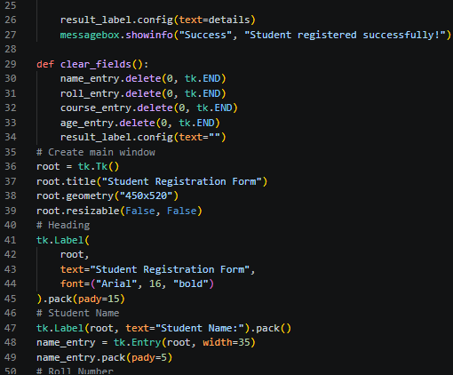
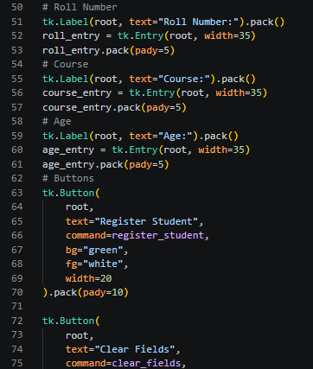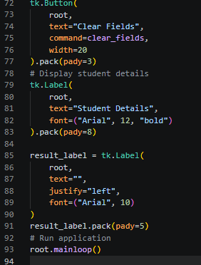
Output:
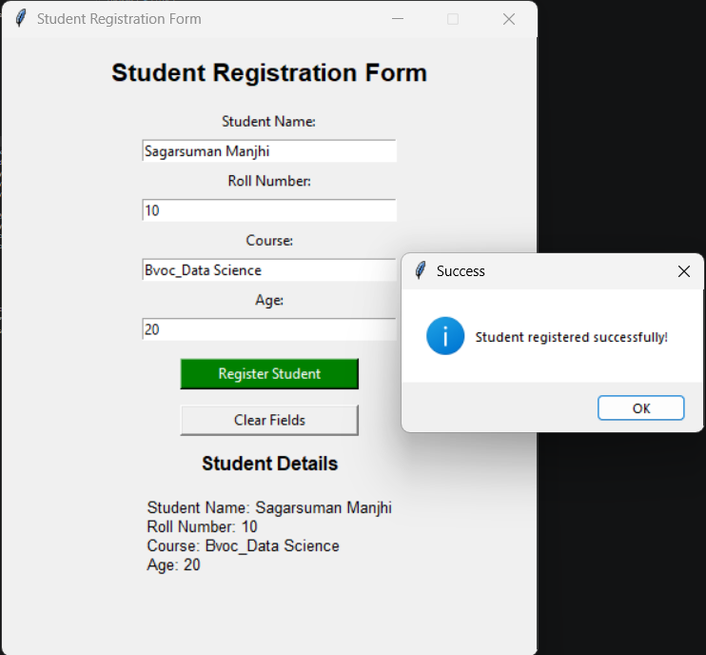
Result and Discussion:
The Student Registration Form was developed successfully using Python Tkinter.
The application provides an interactive GUI with labels, text boxes, and buttons. It accepts student details, validates the entered information, displays a success message, and shows the registered details in the application window.
The Clear Fields button removes all entered values and clears the displayed student details. The application validates that all fields are filled and that the age is a positive whole number.
The program displays the information within the current session but does not save student records permanently to a file or database.

Learning Outcomes:
- Learned to create desktop GUI applications using Tkinter.
- Understood how to use labels, entry fields, and buttons.
- Implemented button-click event handling using functions.
- Applied input validation to student registration details.
- Used message boxes to display success and error notifications.
- Displayed and cleared student information dynamically.
Course Outcomes:
- Understand GUI programming concepts using Python Tkinter.
- Create and arrange GUI widgets in a desktop application.
- Implement event handling and input validation.
- Develop an interactive Student Registration Form using Python.
CONCLUSION :
The Student Registration Form was implemented successfully using Python Tkinter. The application accepts student details, validates user input, displays registration messages, and presents the entered information in the GUI. This practical demonstrates the use of widgets, functions, event handling, and message boxes in developing interactive desktop applications.

VIVA QUESTIONS :
Q1. What is Tkinter?
Tkinter is Python's standard library for creating graphical user interface applications.

Q2. What is a GUI?
A Graphical User Interface allows users to interact with an application through visual elements such as buttons, labels, and text boxes.

Q3. What is the purpose of Tk()?
It creates the main application window.

Q4. What is an Entry widget?
An Entry widget allows users to enter single-line text.

Q5. What is the purpose of Button?
A Button widget allows users to trigger an action by clicking it.

Q6. What is event handling in Tkinter?
It is the process of responding to user actions, such as clicking a button.

Q7. What is the purpose of messagebox.showinfo()?
It displays an informational dialog box.

Q8. What does the get() method do?
It retrieves the value entered into an Entry widget.

Q9. What is the purpose of mainloop()?
It keeps the application window open and processes GUI events.

Q10. Does this program permanently save student details?
No. The details are displayed in the current application session. Permanent storage would require a file or database.

FOR FACULTY USE ONLY :
Correction Parameters | Formative Assessment [40%] | Timely completion of practical [40%] | Attendance/ Learning Attitude [20%]
Marks Obtained

